Contents

1. Introduction 5

1.1. Overview 5

1.2. Technology Implementation in AEC Industry 6

1.3. Development of AEC Industry under Smart City Paradigm 6

1.4. Scope of Research 7

1.5. Statement of Ethics 7

2. Literature Review 8

2.1. Control Room 8

2.2. Control Room Approach in Industries 8

2.3. Control Room in AEC Industry 8

2.4. Research Gap 9

2.5. Framework of Control Room 9

2.5.1. Collaboration Platform 9

2.5.2. Information Management 9

2.5.3. Visualisation – Immersive Virtual Reality 10

2.5.4. Visualisation - Dashboard 10

2.5.5. Open API 10

3. Methodology 11

3.1. Use of available data, software, and service 11

3.2. Framework of Control Room in Construction 11

3.2.1. Data Layer 11

3.2.2. Data Services Layer 12

3.2.3. Application Layer 12

3.3. Source of Data 12

3.3.1. Model Data 12

3.3.2. Project Performance Data 13

3.3.3. Sensor Data 13

3.3.4. Field Condition 14

3.3.5. Sensor set up 14

3.4. BIM 360 14

3.4.1. BIM 360 Collaboration 14

3.5. Microsoft Azure 15

3.5.1. Database Management 15

3.5.2. Streaming of Sensory Data 16

3.6. Visualisation Techniques 17

3.6.1. VR 17

3.6.2. Dashboard 18

3.7. Forge API (Open API) 18

3.8. GitHub Repository 18

4. Result & Discussion 19

4.1. BIM360 19

4.1.1. Document Management 19

4.1.2. Design Collaboration 20

4.1.3. Limitations 20

4.1.4. Recommendation 21

4.2. VR 22

4.2.1. Project Coordination 22

4.2.2. Safety Hazard Identification 23

4.2.3. Limitations 23

4.2.4. Recommendation 24

4.3. Dashboard 25

4.3.1. Identify insight from safety record 25

4.3.2. Monitoring the working environment with Sensory data 26

4.3.3. Limitation 27

4.3.4. Recommendation 27

4.4. External Viewer Application developed with Forge API 28

4.4.1. Limitation 28

4.4.2. Recommendation 28

4.5. Day-to-day routine of Control Room 29

4.6. Evolution in ideal case 29

5. Conclusion (Link to Intro, LR) 30

6. Reference 31

7. Research Log 33

8. Appendix 34

List of Figure

Figure 1 Digitalization Index extracted from McKinsey, 2015 7

Figure 2 Proposed Application Framework of Control Room 12

Figure 3 BIM Model visualised in the Autodesk Revit 13

Figure 4 Modules in BIM360 cloud platform 15

Figure 5 Azure IoT Ecosystem extracted from Microsoft Azure Cloud Service 16

Figure 6 Comparing the difference between models by BIM 360 Document Management 19

Figure 7 Overview of BIM 360 Design Collaboration Module 20

Figure 8 VR Remote meeting 22

Figure 9 Overview of Prospect by IrisVR 23

Figure 10 Dashboard Visualisation by Power BI - 1 24

Figure 11 Dashboard Visualisation by Power BI - 2 25

Figure 12 Data Visualisation by Viewer Application developed by Forge API 26

List of Table

Table 1 Technical Specification of Raspberry Pi and Sensors 14

Table 2 Table Summary of Construction Performance Data in SQL Server Database 17

Table 3 Table Summary of sensor data in SQL Server Database 17

Table 4 Specification of Oculus Quest 18

# Introduction

# Overview of AEC Industry

Architecture, Engineering and Construction (AEC) industry is one of the largest industries in the global economy. There is about $10 trillion spent on construction-related activities over the world annually, which is equivalent to 13 percent of GDP. There is also 7 percent of working population around the world working in this industry (McKinsey & Company, 2017). However, the productivity of AEC Industry is lagging the global productivity by over 30% and 98% of infrastructure projects are over budget or delayed around the world (Changali et al., 2015).

As AEC industry is complex and dynamic in nature (Mohd Nawi et al., 2014), it consists of multiple disciplines at various stages such as planning, design, construction, and operation. The disciplines can be ranged from structural, building services, civil, mechanical engineering teams and architect who are involved from the beginning until the completion of the construction project. Over the years, the project delivery practice among these parties are notorious for poor in collaboration such as isolation of working and inadequate co-ordination. As construction projects can involve thousands of work tasks which are interrelated, so if one individual task is not managed properly, it would significantly impact the quality and productivity of the works in future stages.

Apart from that, the information management in construction is not effective enough. The AEC Industry is labour-intensive and generates enormous amounts of information including calculation, drawings, project reports, tender documents, ...etc which are produced of a construction project. According to a research in China (Xu & Luo, 2014), it has identified and discussed many consequence on the poor collaboration and information transfer among different parties, such as the loss and inconsistent of information caused by fragmentation of parties and unorganised information system. There is a comprehensive statistic of two typical sites in middle and North China, it shows that around 43%, 12%, 3% of the project time lost due to inconsistent information, dislocation, and ambiguity respectively on a construction project in average.

Health and safety deficiency are also one of the main concerns as compared to other industries. The AEC industry has long been recorded with the highest number of death and accident rate compared with other industries globally. It is about 79,000 workers in the construction industry in Great Britain suffered from work-related ill health such as depression and musculoskeletal disorders and 30 fatal injuries in 2019 (HSE, 2019). There was about 62% of construction workers suffering from musculoskeletal disorder. The rate is significantly higher when compared with the rate for workers across all other industries, which is only 1.2% [ibid].

# Technology Implementation in AEC Industry

As the AEC industry is embracing the digital age, the processes involved in the design, construction and operation should be enhanced by technologies such as dealing with value-added monitoring of data and optimisation of engineering systems. However, the AEC industry is far behind to adopt new technology compared with other industries. The digitalization index of construction is very low as shown on below figure (McKinsey, 2015).

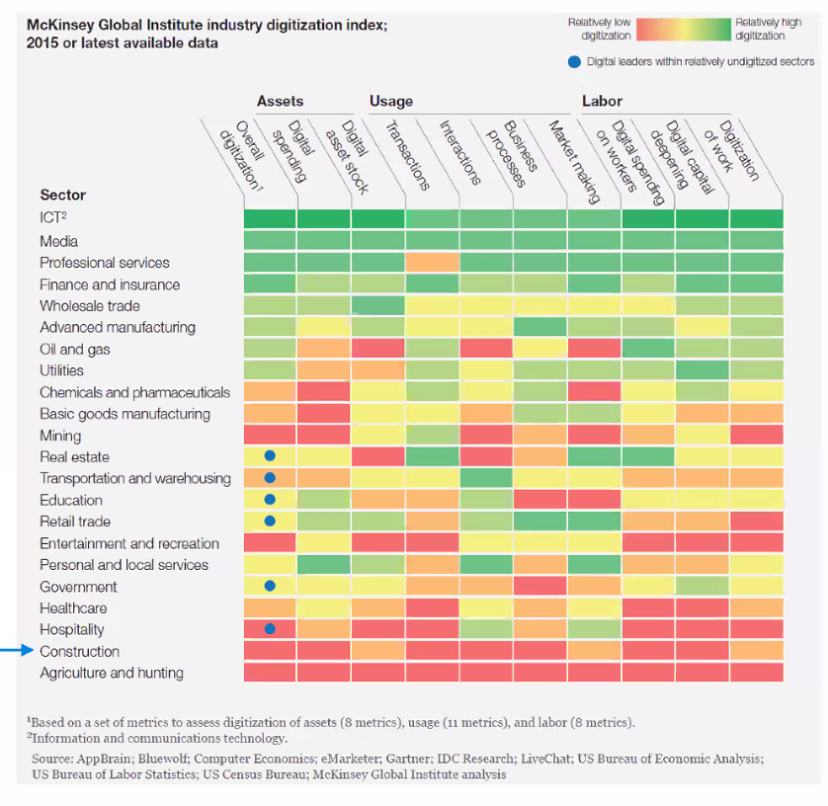

Figure 1 McKinsey Global Institute industry digitalization index (McKinsey, 2015)

Although the industry has recognised the need for change and adopted many technological solutions such as Building Information Modelling, Virtual Reality, ..etc , they are fragmented point solutions (Woodhead et al., 2018). This system should be with high connectivity between hardware, software and making key decisions based on data (ibid).

Besides, as the explosion of global pandemic COVID-19 is accelerating the development of digital transformation in different industry (ref). With unprecedented consequences such as the disruption of manufacturing and supply chains, the mitigation to the impact by COVID-19 requires new approach of working and forms of collaboration such as remote working among team members to increase overall resilience of the business with technology.

# Development of AEC Industry under Smart City Paradigm

Nowadays, the smart city development strategy is embraced over the world, which is focused on “citizen centric” (Lara et al., 2016). It proposed that the technology should be citizen-focused, the developer must understand their citizens need and develop appropriate technologies which will be beneficial to them. This citizen-centric value defines the initiative Project 13 in AEC industry, which aims to develop a new business model for delivering high performing infrastructure to the ultimate user (i.e. the citizen). There is an ‘Integrator’ character which can be a single company or a collective party who plans and delivers the infrastructure programme, manages the suppliers and advisors, oversees design, construction, maintenance and operations as requested by the owner (Engineers, 2018). Most importantly, it pointed out that the Integrators should bring together capabilities to deliver effective solutions through production systems and enables a platform approach to deliver the project stipulated under the “Integration” pillar of the five pillars in the initiative (ibid). Regarding to this, an integrated platform such a Control Room should be considered to improve the project delivery in AEC industry.

# Scope of Research

The major scope of research of this study is as follows:

* Explore what are the features of the Control Room for AEC industry

* Explore how the Control Room’s features to improve the project delivery based on available solutions in the market
* Explore the improvement on Control Room’s features based on the evaluation on current available solution

# Statement of Ethics

All the data used in this study do not contain any personal information. Therefore, no ethics approval was required.

# Literature Review

# Control Room

The Control Room idea was originated in 1920s, which is for production control and monitor the physical facility in a central space (Bennett, 1993) . In 1970s, the launch of Apollo 13 program by NASA make use of the Control Room for monitoring the outer space condition (Jarrett Hendricks, 2020). The engineers on the ground Control Room needed to response the changes swiftly to the space vehicle and the astronauts exposed to the extreme conditions in outer space. Later, NASA identified that they can no longer make corrective decisions based on the original modelling method because the actual module had subjected to significant changes due to the exposure under extremely hostile environment. It was necessary to update the original modelling method so that the actual state of the module could be closely simulated. As a result, they used the “pairing technology”, which is  the precursor to digital twin technology, to simulate the outer space with the mathematical models so that the engineers and different professional could collaborate in the Control Room on ground and made decision based on that mathematical model (ibid). The core idea of the digital twin paradigm is to create a virtual asset to represent the physical assets, which helps to make better-informed decisions to improved outcomes in the real-time (Bolton et al., 2018).

It shows that the framework of the Control Room approach as follows. First, it should be a platform which can enhance collaboration. Second, it should include digital models paring with the physical facility and the data obtained can be visualised and analysed. Third, there is protocol of the digital model that exchange data with the physical facility. This framework of Control Room is related to the concept of digital twin, which various industries are embracing.

# Control Room Approach in Industries

In the product manufacturing industry (Yi et al., 2020), a digital twin based production management and control approach has been used. The product digital twin acts as a single data source for the vendors to collaborate each other throughout the product lifecycle such as product design, process planning, product assembly, product use and maintenance. In an assembly shop-floor scenario, data visualisation and integrated management of shop-floor data based on digital twin is achieved. For example, the assembly shop-floor digital twin is composed of shop-floor production elements’ geometric models and physical models such as shop-floor model, production line models, assembly station models, manufacturing resource models, product models, and environment models. These 3D geometric models are developed by Pro/E, CATIA, SolidWorks, AutoCAD and so on.

In the financial industry, an Africa’s bank used the Control Room approach to monitor the sensitive corporate information flow from a multi-service financial institution. It acts as the company’s nerve centre to monitor the deals data such as mergers and acquisitions, equity offerings, debt offerings, …etc. The deals themselves are very complicated and generate an enormous amount of data that must be monitored closely to ensure the deal data can be organized, recorded, and analysed. It keeps track on who are involved in the deal, what are their deal and who agree with that deal, there is extremely little room for error for the deal data (StarCompliance, 2019).

It shows that the Control Room approach can address the need and problems in different industries by enhancing the collaboration, data visualisation and getting insight from the data.

# Control Room in AEC Industry

AEC industry has similar nature as the above-mentioned industry, the infrastructural generates enormous amount of data during the entire project life cycle, if any data got error or inconsistency between the documents such as the design information is not consistent in different drawings, the project progress and productivity would be greatly affect. It also involved multi-discipline stakeholders for collaboration in the projects. As a result, a Control Room should also be used to enhance project management and reduce risk like project delay, over-budget and minimise contractual implication and safety deficiencies.

As Building Information Modelling (BIM) store various types of information during the building process, to utilise the digital twin paradigm for the Control Room in AEC Industry, many professionals embrace that BIM should plays an important role with it to form an integrated approach (Boje et al., 2020). It also pointed out that BIM should be integrated with another application such as control systems such as IoT devices although BIM lack semantic completeness due to its legacy data format.

--------------------------Digital Twin---------------------------------

# Research Gap

Most of these literatures has just pointed out the conceptual framework and the advantages of using the digital twin-based Control Room approach in the industry. However, there is less research on how to build the digital twin practically, the technical challenges and case study to show how does it work in the AEC industry. For example, the details of architectures to form the Control Room and how to link them all together to solve problem practically are omitted. Unlike those studies, this study will outline the features of a digital-twin based Control Room in the AEC industry.

# Features of Digital-Twin based Control Room

Upon the literature review, four features have been identified of a digital-twin based Control Room: Collaboration, Information Management, Visualisation, Open API. (why important)

# Collaboration Platform & Information Management

It should be a platform to foster the collaboration and information exchange between different disciplines. Traditional tools such as email, project management software and telephone are just one-way communication activities. They lack the real-time collaboration elements which is for connected engagement, discussion and approval process (Levine, 2016). If different parties in the project can submit updates of information on a simple and real-time manner on a single platform to create a single source of truth (i.e. common data environment), it will be easier for all project team members as one and remain on the same pace as the project proceeds, so it would not make the progress delay in terms of scheduling and over-budget due to rework.

# Visualisation – Immersive Virtual Reality

Immersive Virtual Reality (VR) can give the user feel like physically presenting in a computer-generated environment simulating places in the real or imagined worlds. It is common used in the education and training purpose by its potentials of provide an interactive and motivated environment (Freina & Ott, 2015). Besides, many publications have identified various areas that VR technologies have been implemented to enhance safety (Alizadehsalehi et al., 2019), such as risks identiﬁcation, workforce training, skill transfer and ergonomics in the AEC industry (Li et al., 2018). While VR can also be used for meeting with team members to work together within a 3D model for discussion, which is benefit for remote working (Brandon, 2020). All these literatures showed that VR device is an effective tool for enhancing the interaction between human experiences and building environments.

# Visualisation - Dashboard

Dashboard visualisation is a cognitive tool to improve our “span of control” over the business data. This help the managers to identify trends, patterns, and anomalies from the data. Managers can figure out the reason about what they observe and as a guideline for them to make effective decisions. Besides, Key Performance Indicators (KPIs) is commonly used to benchmarking and compare performance by meeting both strategic goals with a dashboard in different industry. The analysis results can help to improve the building processes and risk identification for project delivery. It is the topmost priority for Project Directors, Project Managers and any other person responsible for planning management to implement a better planning process by having a clear view of the project’s status.

# Open API

Under the context of smart city, the availability of information can create opportunities to get insight from the city's activities through modeling and analysis of data from different domains (Belizario & Berardi, 2019). This smart data solution can be used to get insight and able to manage cities data strategically (ibid).

As a result, the Control Room platform should provide open Application Program Interfaces (API) such that the third-party developers can develop external applications and able to utilize the function of the Control Room platform. It motivates more developers to improve the functionally of the entire Control Room system and make good use of the data.

# Methodology

# Research Method

This study will make use of services and software available on the market as different features of a digital-twin based Control Room and they will be evaluated with a case study of the residential house design and built project[1] from the Contractor points of view. These features will be evaluated by the author himself based on his personal experience such that a clear view on how a Control Room should be developed on the **features of collaborating, information management, data visualisation and Open API.**

# Framework of Control Room in Construction

Available service and software in the market have been allocated into different layers of framework for the Control Room as below figure. It composed of 3 layers which are the Data Layer, Data Services and Application layer.

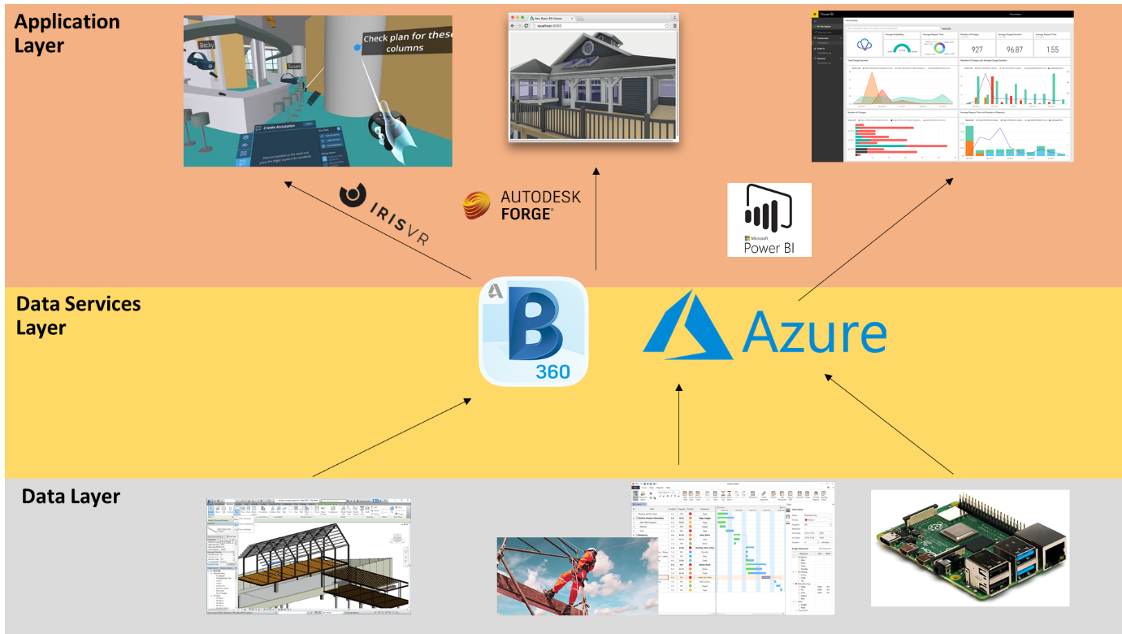

Figure 2 Proposed Application Framework of Control Room

# Data Layer

Each of the component (from left to right) in the data layer represents an aspect of the construction site to reflect the performance.

1. Model data: the digital model of the physical configuration of the building
2. Project performance data: Safety data
3. Sensory data: Working condition of the construction site

# Data Services Layer

It forms the core part of the Control Room. The model data can be published to the BIM 360 cloud platform for collaboration so that different project team members can work remote and modify the model data on a single source of environment. Besides, the Microsoft Azure Services provide a platform to storage and process the data. The project performance data and sensory data will be stored in a SQL Server database which is created with Azure Services. The data can be retrieved to feed into the elements in application layer for visualisation.

# Application Layer

The application layer demonstrated the data visualisation features of the Control Room. Model data in BIM 360 will be visualised in VR environment with the software “Prospect” developed by IrisVR. The project performance data and real-time sensory data will be visualised with dashboard by Microsoft Power BI. While the Autodesk Forge API will be used to retrieve the data from BIM 360 to develop external application such as viewer applicaiton. There details will be discussed in Section 3.3 to 3.5.

# Source of Data

All the data used in this study will be modified from different source to fit into the novel of the case study.

# Model Data

The model data is a template file provided by Autodesk Revit 2020 with format of “.rvt”. The 3D model can be visualised as the below figure:

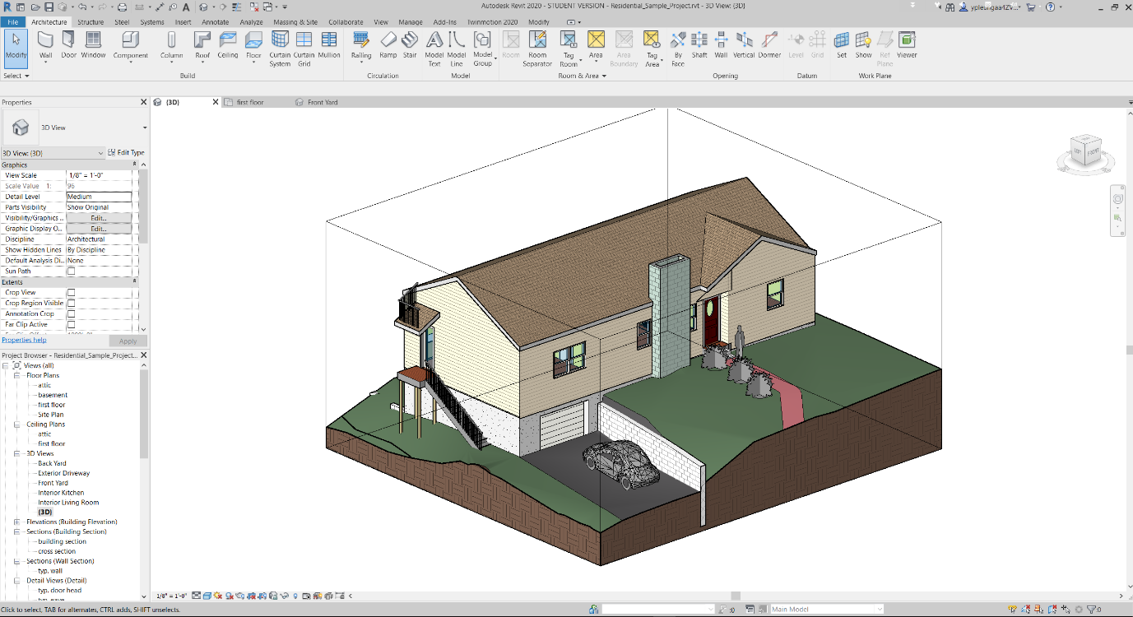

Figure 3 BIM Model visualised in the Autodesk Revit

The model contains objects data relating to the architectural and structural elements. All objects in the model contained information such as object name, type ID, furniture name, material information and major dimensions in object property. All the model data would be processed by Autodesk Revit first and would be published to BIM 360 online to simulate the collaboration features of the Control Room.

# Project Performance Data

One dataset of project performance data used for this study is modified from the data provided from the ‘Project Hack 5[2]’ hackathon organised by Project Data Analytics Community. It contains all incident record of the construction project of the residential house from 2016 to 2020, it includes detailed information with 139 rows and 15 columns, such as date of accident, accident category, nature of injury and damage classification and type of contact.

# Sensor Data

Low cost microcontroller Raspberry Pi (RPi) has been selected as the prototype of IoT devices to capture the construction environment data. RPi is a Linux-based platform. It is a credit card-sized computer and can be as an alternative of a desktop computer. As it is low cost and support different operating systems, it is suitable for ranges of projects such as acting as IoT device. The version used in this study is the Raspberry Pi 4 Model B which is newly released on the end of May 2020. The RPi can connect with local area networks with WIFI and transfer the data received from the sensors to Microsoft Azure IoTHubs services, which will be explained in Section 4.4.1. The technical details are given in the below Table:

Table 1 Technical Specification of Raspberry Pi and Sensors

|  |  |  |  |
| --- | --- | --- | --- |
| **Component** | **Image** | **Relevant Technical Data** | |
| Raspberry Pi 4 Model B | Raspberry Pi® 4 B 4 GB 4 x 1.5 GHz Raspberry Pi® | Conrad.com | Cost:  RAM  Processor  Operating  Voltage | 68 pounds  8GB  Broadcom BCM2711, Quad core Cortex-A72 (ARM v8) 64-bit SoC @ 1.5GHz  5V DC via USB-C Connector (minimum 3A) |
| SHT20 | SHT20 溫濕度傳感器模組I2C 通訊- 台灣物聯科技TaiwanIOT Studio | Cost  Interface  Temperature Range  Humidity  Range  Operating Voltage | 3 pounds  I2C  -40oC to +125 oC  0 to 100%  3.3V |

Figure to show final configuration of the Raspberry Pi with sensor installed.

# Field Condition

Under the disruption of COVID-19, it is hard to find an actual construction site for capturing the sensory data for our study. As a result, the sensory system had installed on a local factory which manufactures hangers in Hong Kong to simulate the working condition of a construction site and the ability of the sensor to collect the empirical data. The usable area of the factory is around 75 sq. feet and height 12 feet. One worker is working in this factory from 09:00 to 17:00 from Monday to Friday to keep on monitoring and maintaining the machineries which produce the hangers and process the raw material inside the factory. The temperature and humidity of working environment will be impacted when the machineries are operating. As a result, it is a reasonable location to be chosen to simulate capturing data in a construction site.

-> general layout of site (photos)

# Sensor set up

For this study, only one sensor box will be installed at the factory for demonstration purpose. The experiment will run for a duration from xx:xx:xx to xx:xx:xx on xx August 2020. The data obtained will be processed as discussed in Section 3.5 and will be used to visualize with the BIM data.

(photos)

# BIM 360

# BIM 360 Collaboration

BIM 360 is a common data environment (CDE) and a collaboration platform. This cloud service is used to demonstrate the collaboration and information management features of a Control Room. On the “Project Home” page of this platform , it allows users to add different customised card such as the status of the project issue, RFI, model and even insert the Power BI dashboard, which provide a great integration capability to organise different kinds of information for the Project Engineers to Project Director. A snapshot of Project Home page is shown on the below figure:

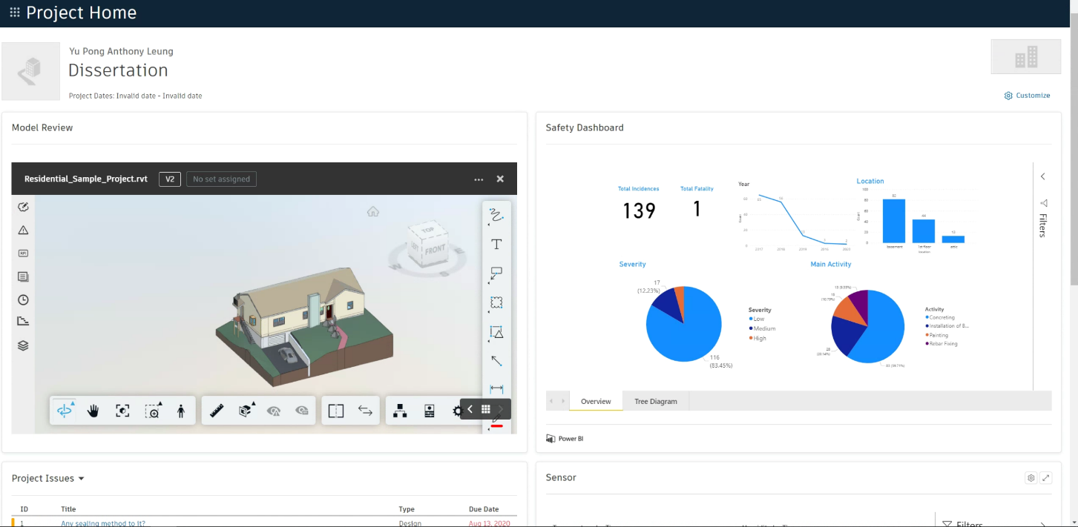

Besides, this platform provides different modules to enhance the collaboration of different parties. The modules such as “Document Management”, “Project Management” and “Design Collaboration” will be used in this study. As a construction project contains lots of drawings and BIM model data, these documents will be stored in the module Document Management which supports version control and provides ways to keep track on every single step on the workflow. The Project Management module provide …… . Design Collaboration module will be used to show how BIM model packages be created by different parties on a timeline and will allow them to decide whether to consume these packages for their further amendment on the BIM model. This service has been used in this study since it is the only one solution that provides trial version for education purpose in the market.

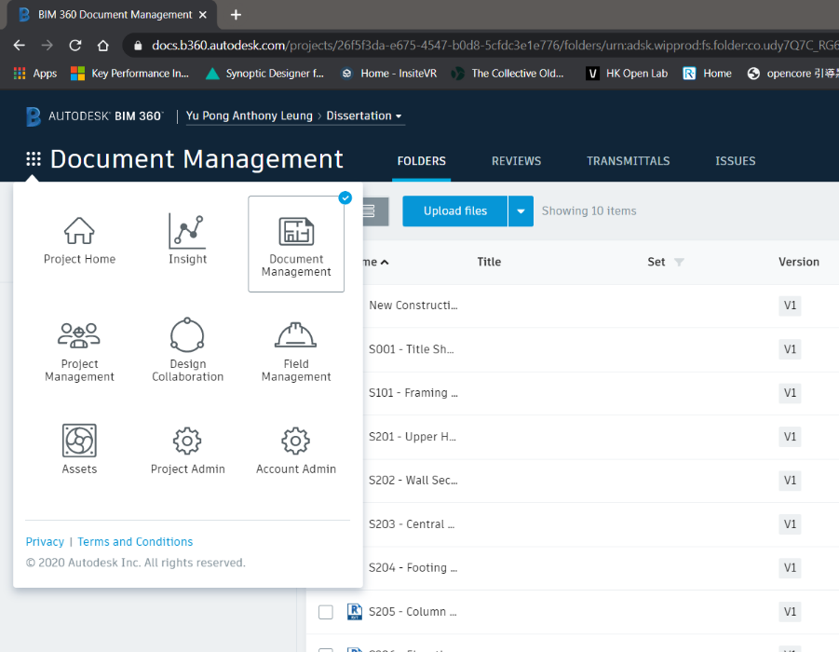

Figure 4 Overview of modules in BIM 360

# Microsoft Azure

Azure is used to demonstrate how it support the information management and data visualisation features of the Control Room in this study. It offers cloud service in three main categories: Infrastructure as a Service (IaaS), Platform as a Service (PaaS), and Software as a Service (SaaS). PaaS will be focused on this study. Platform as a service (PaaS) is a cloud-based development and deployment environment, with resources to deliver our own applications.

PaaS not only includes the elements of IaaS such as servers, storage, and networking, it also provides middleware, development tools, business intelligence (BI) services, database management systems and so on. It is designed to support the full development of the lifecycle of a web application like building, testing, deploying, managing, and updating. Compared with other cloud service, the Azure also provides a user-friendly environment and tools for the developer to build their own application, the building blocks is clear to build the new application. Also, as Azure support directly push the real-time data to Power BI, which provides an easy way to set up real-time visualisation of sensory data.

Microsoft Azure cloud service is the only one in the market to offer a free tier one-year subscription for students, which is a great choice for this study.

# Database Management

Azure SQL Database is a fully managed PaaS database engine that handles most of the database management functions such as upgrading, patching, backups, and monitoring without user involvement. With Azure SQL Database, a highly available and high-performance data storage layer for the applications and solutions can be created. It also allows the process of both relational data and non-relational structures, such as graphs, JSON, spatial, and XML. A python script (Appendix XX) was used to insert the performance dataset which is in .csv format. It established a connection to the SQL Server with the required credentials and perform inserting to the database. Python Libraries such as panda and pyodbc will be used for data processing and building connection with the SQL Server.

Table 2 Table Summary of Construction Performance Data in SQL Server Database

|  |  |  |  |
| --- | --- | --- | --- |
| **Table Name** | **Field** | **Type** | **Description** |
| SAFETY |  |  |  |
|  |  |  |  |
|  |  |  |  |
|  |  |  |  |
|  |  |  |  |
|  |  |  |  |

# Streaming of Sensory Data

For the sensory data, the sensor with the microcontroller Raspberry Pi (RPi) act as a node and registered as an ‘IoT devices’ in Azure IoT Hubs. The Python script (Appendix xx) has executed on the RPi to connect with the IoT Hubs. RPi has set to send data every 10 seconds. By using the IoT Hubs services as the gateway, the data can be further processed with the Stream Analytics to push to another application as below figure referenced from the Microsoft Azure Cloud.

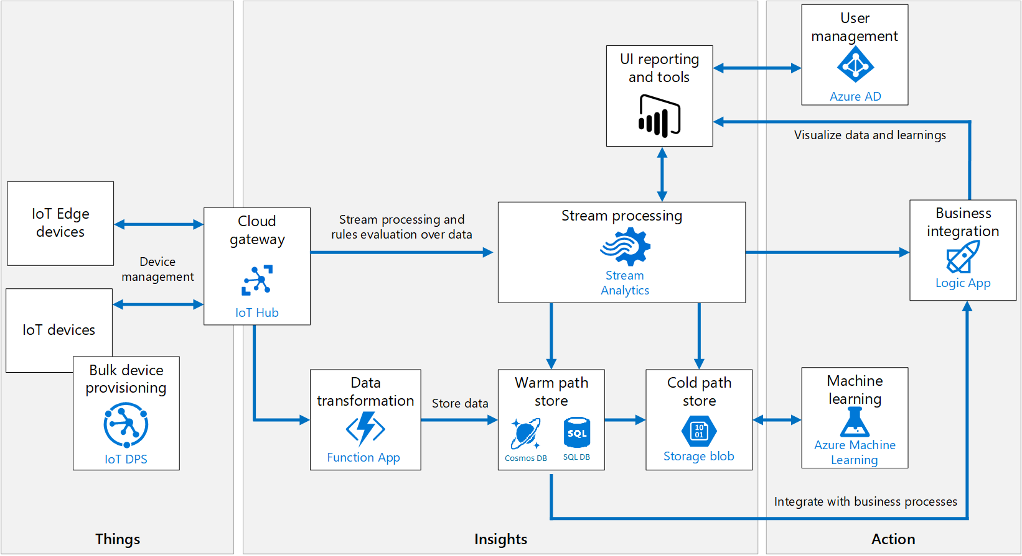

Figure 5 Azure IoT Ecosystem extracted from Microsoft Azure Cloud Service

Azure Stream Analytics is a real-time streaming engine that is designed to process high volumes of fast streaming data from multiple sources simultaneously. Once the relationships between input sources RPi in IoTHubs and output sources such as streaming as a dataset in Power BI has been formed, it will trigger the streaming of real-time sensory data from IoT device to Power BI.

(Chart with streaming of input / output data)

Figure 6 Extract from Azure Stream Analytics

The parameters obtained are tabulated as below. These parameters are added dynamically as a new row in the dataset “sensortest” of Power BI during streaming.

Table 3 Table Summary of sensor data in Power BI

|  |  |  |
| --- | --- | --- |
| **Table Name** | **Field** | **Type** |
| sensortest | ConnectionDeviceGenerationID | Text |
| ConnectionDeviceID | Text |
| CorrelationID | Text |
| Enqueued Time | Date/Time |
| Humidity | Decimal Number |
| MessageID | Text |
| Temperature | Decimal Number |

# Visualisation Techniques

# VR

The add-on of Autodesk Revit named “Prospect”, which is developed by IrisVR will be used for VR visualisation, the model data in BIM360 can be opened in Revit and the model will be converted for VR visualisation by using this plug-in. It can create a narrative for the VR experience which is in 1:1 scale. Besides, Prospect is the only one that include all utility features such as measurement, mark-up, snapshot, section view and object information in a single add-on compared with others in the market and it provided free-trial for 14 days, so it has been chosen for this study.

The immersive VR headset Oculus Quest will be used for this study. It is a completely wire-free, PC free and with all the sensors built in. The specification is as follows:

Table 4 Specification of Oculus Quest

|  |  |
| --- | --- |
| Display panel | OLED |
| Display resolution | 1440 x 1600 per eye |
| Refresh rate | 72Hz |
| CPU | Qualcomm Snapdragon 835 processor |
| RAM | 4GB RAM |
| Battery | Lithium-ion battery with 2-3 hours playtime, depending on what you are playing |
| Degree of Freedom | 6 degrees of freedom head and hand tracking |
| Controllers | Two touch |
| Weight | 571g |

# Dashboard

As Power BI can get data from a large numbers of source such as Azure SQL database and Streaming Analytics after the connection has been set up, a dashboard created by Power BI will be used to visualise the construction performance data and sensory data. Also, whenever the data has been sliced or another field has been updated in the data source, one can just click the refresh button in Power BI to make a new query to update data. It also supports publishing to the internet as a report and embedded into other websites such as BIM 360, which enhance the integration with the CDE. As a result, it has been chosen for this study.

# Forge API (Open API)

Forge API is used to retrieve or push the data to BIM 360, it is the native API provided by Autodesk. It comprised of multiple APIs for retrieving different kinds of data for specific group of tasks related to the Autodesk cloud ecosystem. The data in BIM360 such as model data, checklist, issues can be further developed for automated processes, workflows, and data visualisation. All the available API can be explored on forge.autodesk.com.

A viewer application has been built to review whether this API feature is easy to use. This viewer application provides a way for the external stakeholders and non-technical person (e.g. public) to read the BIM model data, which allow them to see rich design information, organized by property and visualise in 3D modes.

# GitHub Repository

(Github link: ), link of other application, video

# Result & Discussion

The result focus on how to make use of the features of Control Room to manage the information, enhance the collaboration between different parties, get insight and sharing data based on the case study of residential house project.

# BIM360

# Document Management

The module “Document Management” provides ways to identify the change of information effectively. Under the case study of the Residential house Project, the structural team members want to find out what additional architectural features has been added in the model file, they can compare the versions of the model and all the additional features can be highlighted as below figure. The features which are highlighted in green is the additional elements added by other team members and the part highlighted in yellow indicate the structural that has been modified.

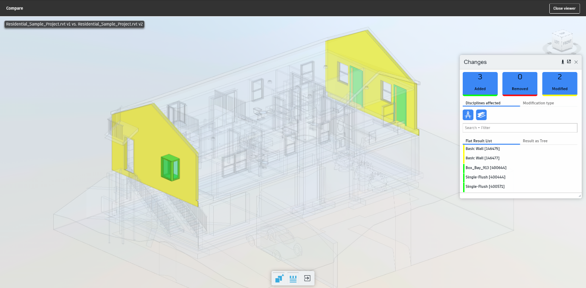

Figure 7 Comparing the difference between models by BIM 360 Document Management

The quality assurance process of information can be enhanced by the workflow approval. The workflow is a set of step-by-step rules that the engineers should fulfil to make sure the quality of documents like BIM model fulfil certain standard to approve.

After the structural engineer have identified the changes of model by Architect and added the respective structural elements to support the Architect’s change, he would like to submit to his designated team members to review, he can select the model and choose the desired workflow and assign to other team members for review. An email notification window will be automatically sent to the team members afterwards. Then, the reviewer can make mark-ups and add comments to the model. And the reviewer can give back to the project engineer for amendment and the workflow only can go to the next step only when all the comments has been resolved.

This ensure the quality of the information that it should be compromised and go to the next step and no need to spend extra-time to return to previous step to re-do the works under the traditional working practice as there is no strict workflow approval procedure before. Also, it can record who have already received the notification for review the document and who need to answer the queries by other team members, so it push the team members act on time to increase the productivity in the project delivery.

# Design Collaboration

The “Design Collaboration” module provides a clear way to enhance the collaboration with different team members. After the structural team member have finalised their changes of model data, they can publish the model data to BIM 360 for the architectural team further amendment. For example, they have modified the model with extra structural elements such as beam, columns and walls based on that model. Once they have completed the modification, the structural engineer can synchronize and publish the model data to the BIM 360. On the web-platform of BIM 360, the structural engineer can create a package in the timeline as shown on below figure so that the packages can be shared to other team such as the architectural team to consume this model and keep on modify it.

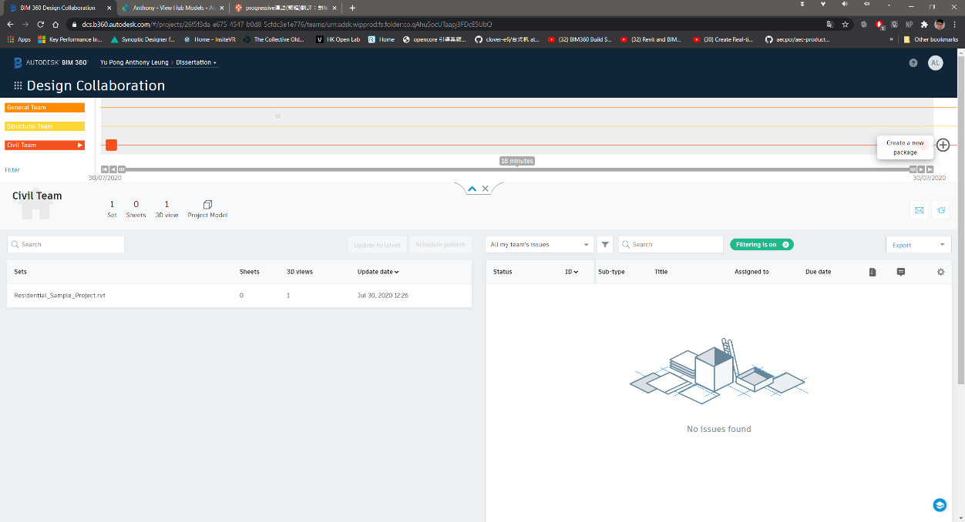

Figure 8 Overview of BIM 360 Design Collaboration Module

This is the concept of the design collaboration loop which is a set of collaboration procedure can achieve a continuous and smooth handover of the model data between different team members.

# Limitations

These module features play a good illustration of how the collaboration and ensure the information management should be of a Control Room. However, the “design collaboration” module is a bit complicated and it created multiple model data files which may lead to confusion.

For example, after the publish of the model data by one team member to the BIM 360, the model will be saved in the folder of “WIP (Work in Progress) folder”, which is created automatically under the work breakdown structure of the design collaboration module. Besides, as the user need to create a package to share to other team members, the model data will be saved in “Shared” folder for sharing to other team members for consume. And finally, after the model has been consumed, the model will be saved in the folder named “Consume”. As a result, multiple model data files have been created by using this design collaboration loop concept and it may make confusion to the beginners that they do not understand which model they should be used to work with if they are not familiar with the design collaboration concept.

# VR

# Project Coordination

The VR visualisation shows a great enhancement in collaboration for different team members. First, the residential house model data has been parsed with the software “Prospect”. Different team members can either fully immerse in the 3D models data with the VR headset (figure on right) or visualise the 3D environment with the computer (figure on left). It gives a great perception for the project team members to understand how the construction environment would be instead of imagination from the traditional drawings.

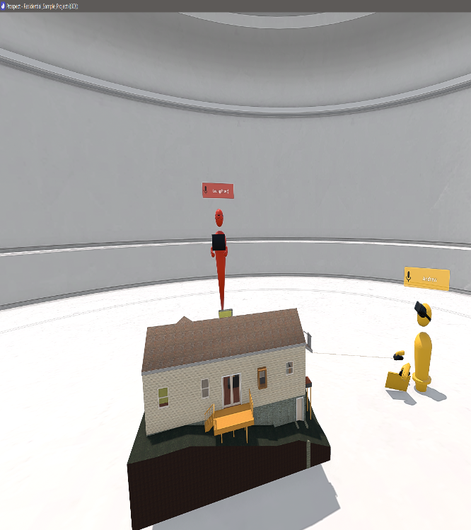 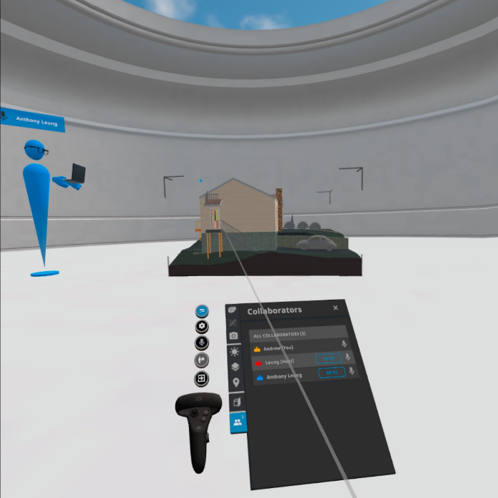

Figure 9 Different Team member immerse in 3D environment

Team members can also carry out VR remote meeting to review the modification need from team members. For example, they can make use of the utility features such as measurement, mark-up tools, object details and sectional view for the user to present their idea during the remote meeting effectively. The building service engineer (blue) can use the mark-up tool to add annotations and comments on the ceiling of a specific room so that the structural team member (yellow) can adjust the setting out of the structural beam to avoid crash with this building services utilities during VR inspection. The video link of the demonstration is …

(charts)

After they have agreed how they would modify their design and the construction sequence in the VR inspection, team members can have a clear understanding of the need of other members. They can amend their own respective data model and combine with the use of design collaboration module in BIM 360. As a result, different team members can modify the model effectively and avoid crash of elements, which greatly increases the productivity.

# Safety Hazard Identification

Besides, it is a good tool to identify locations with safety hazard. As the user can visualise the model from it very beginning to the final completion stage. All the safety hazards during the construction can be identified and find out the exact locations with the high risk of safety deficiency such as confined space, locations which easy to fall from height. For example, the balcony at the west evaluation of the residential house which is above ground for 2.45m meters and at the edge location, which is highly susceptible to the hazard of falling from height. This can help the managers to arrange special training for workers such as working on height and pay more attention to this location during the construction of the balcony.

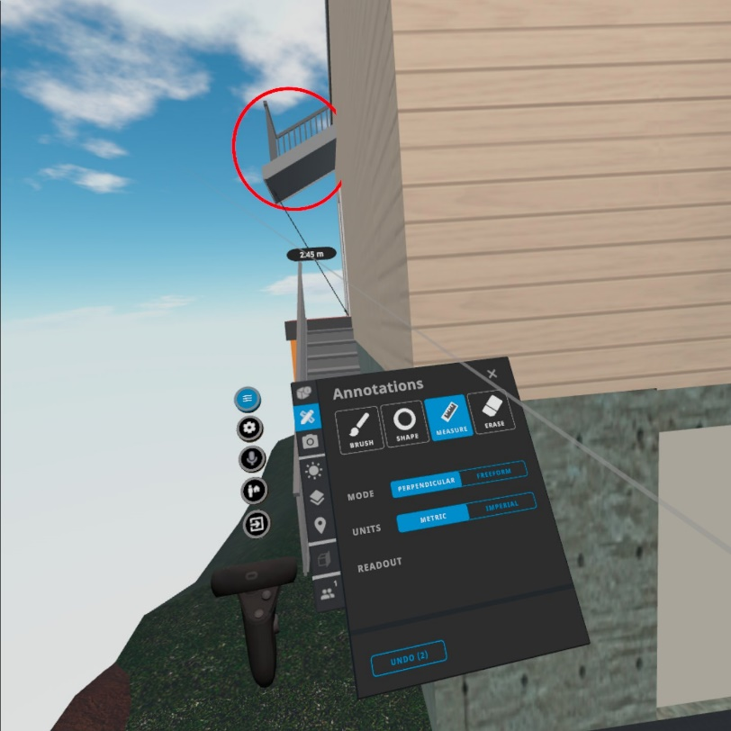

# Limitations

VR can provide a great environment for collaboration and identify location with safety hazard for the users. However, the subscription cost is quite high and often exists as a separated plug-in or services rather than integrated with the collaborate tools. It made individual need to pay extra cost to buy this service to use, which lower the motivation for the construction professionals to adopt this technology. According to two services providers like “IrisVR” and “the Wild” which can function as a plug-in with Autodesk BIM360 and Revit. Their monthly subscription is about $225 USD and $295 USD, which is not an affordable price for some company especially some small size company to adopt this solution.

Besides, the compatibility of add-on of “Prospect” should be improved. For example, one must need to open the local desktop software Autodesk Revit to load the model data from the cloud BIM 360, and use the VR plug-in in Revit to transfer the BIM model data its external VR software “Prospect” to parse the model data so that we can visualise the immersive VR environment on the external software which shown on the below figure. It is quite not user-friendly. To make it more user-friendly, it should be integrated in the cloud platform of Control Room (such as the BIM 360), so that when all the project team members access to the cloud platform, they can open the model file and then press one button to access the immersive VR environment for walkthrough and remote meeting immediately rather than installing external software and so many steps to start with the visualisation with VR.

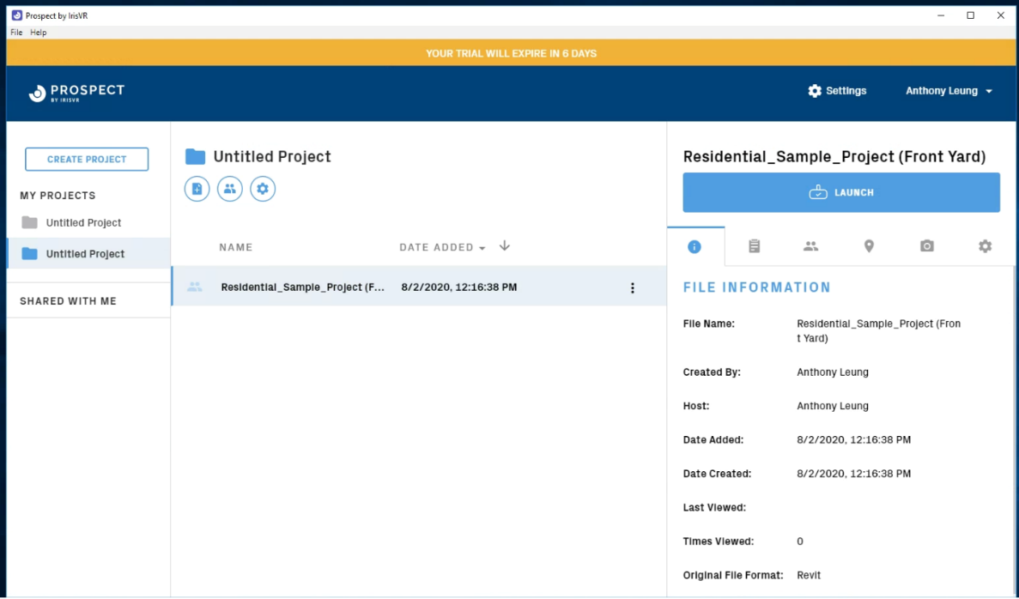

Figure 10 Overview of Prospect

# Recommendation

# Dashboard

# Identify insight from safety record

In the first dashboard, we can identify that the trend of the number of accidents of constructing the residential house is decreasing across the years from 2017 to 2020 and the basement with the highest number of accidents. One can choose whatever categories under different indicators such as “Severity”, “body part”, “main activity”, “Risk Category” and “Injury Type” so that the total number of fatalities, incidences and the number of accidents across different years will be changed. It is easy to identify most of the accidents belongs to the activity of concreting , category of risk with slip or trip on the same level, workers suffering from body parts such as leg and the severity of most of the case is low. (The dashboard file is on…)

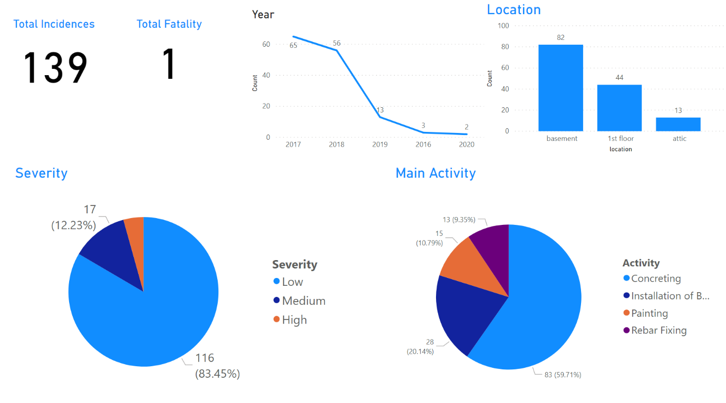

Figure 11 Dashboard Visualisation by Power BI - 1

According to these messages provided via this dashboard, the project managers should pay more attention to the activity like concreting and the location of basement. The managers can make investigation to see what lead to the workers suffering from high risk of accident in the basement when concreting. Besides, the managers can provide more personal protection equipment to protect the legs of the workers.

Besides, the second dashboard use a tree level diagram, which shows the root on how to constitute the number of accidents. The tree diagram has separated into different levels, the first one is “nature of injury”, second is “activity”, third is “location” and the last one is “no of day lost”. For example, when we selected one of category under the first level “severity”, then the number of accidents will be separated into different groups under the second level “location’”. And then it will separate into different groups under the third level “activity”, when we click one of the group, the number of accidents will be separated in different groups again under the forth level ‘body part’, so that we can identify the number of accidents based on different level of a specific root.

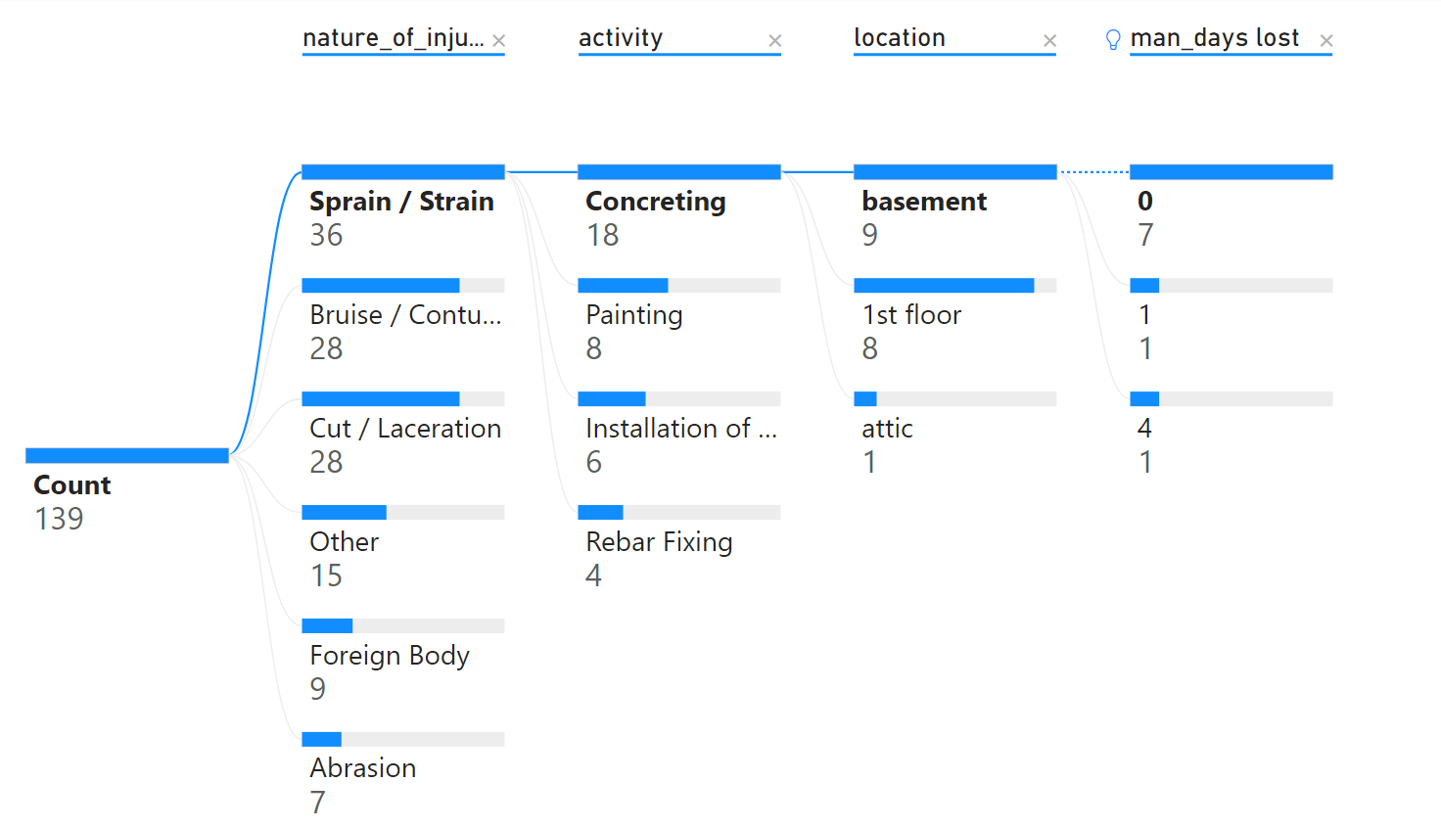

Figure 12 Dashboard Visualisation by Power BI – 2

The Project Managers can easily identify which construction activities at where to cause different types of the nature of injuries and the productivity lost. It gives a chance for the project manager to identify each nature of injury concentrated on what activities and where its location and how to affect the productivity lost, so the manager can understand where should pay more attention to mitigate the risk of injury and how it would affect the man-day lost.

# Monitoring the Working Environment

The real-time sensory data has been visualised with line chart in Power BI dashboard. Overall, xxx data points were collected on [date]. The variation of the temperature and the humidity of the working environment has been captured on the below figure.

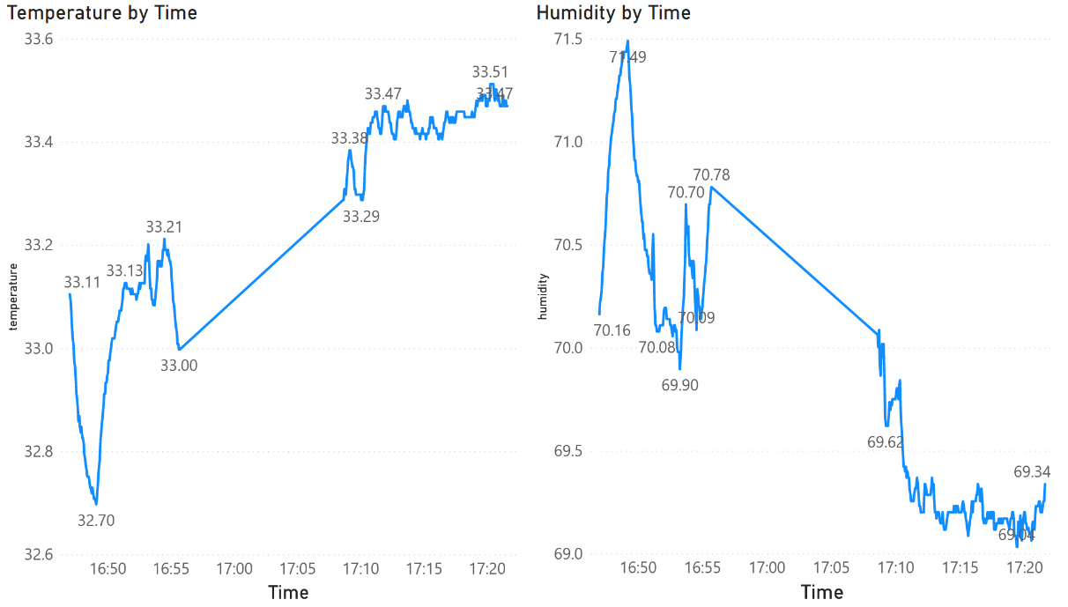

Figure 13 Line Chart Visualisation of Sensory Data by Power BI

The project engineer can make use of the sensory data to monitoring the working environment of the workers. If the temperature and humidity achieved a level not suitable for the workers to work, the project engineer can ask the workers to take regular break.

# Limitation

The Power BI is a great platform to present the data to give insight, pattern and abnormality. However, based on the availability of the dataset, the author cannot find data to establish a KPI for monitoring the construction performance. The maybe due to as AEC industry is complicated in nature, different construction companies will have their own standard and indicators to report the project safety, progress related issue and workflow for quality assurance process. As a result, there is no common objective benchmark for the AEC industry to compare the construction performance such as construction KPIs. The AEC industry should try to agree a set of KPIs so that the construction performance of every company can be compared based on these KPIs and the dashboard features of the Control Room system can make use of this common standard for comparison.

Besides, the project manager should not misattribute causality when comparing elements on the dashboard. The dashboard result show that most of the accident record concentrated on the location of basement while the number of accident on the attic is the lowest, but it just means the location of basement is more likely to have accident compared with attic based on the old record, the project managers should also think about the nature of the construction works whether it is different from the basement so that the old record can not be as the sole guideline to set up safety policy and resource allocation to mitigate the problem.

# Recommendation

For the use of sensory data, a more accurate result of the working environment can be achieved by installing multiple sensors at different location so that the environment data would not be biased on one location. However, it would cost much higher and the project manager maybe no motivation to this technique if the sensory data cannot give a big return. Apart from that, dashboard is not the best way to visualize the sensory board, it would be much for useful if it can be visualized in the VR environment so that it gives a much better perception of the status of working environment during remote working. However, it involved high technical knowledge and still developing for practical usage recently.

# External Viewer Application developed with Forge API

An external viewer application has been developed to provide means for the external parties such as the public to understand what the final product of the project is. The viewer application provided a toolbar below the 3D model for the users to navigate the model and read the building data stored in each building elements.

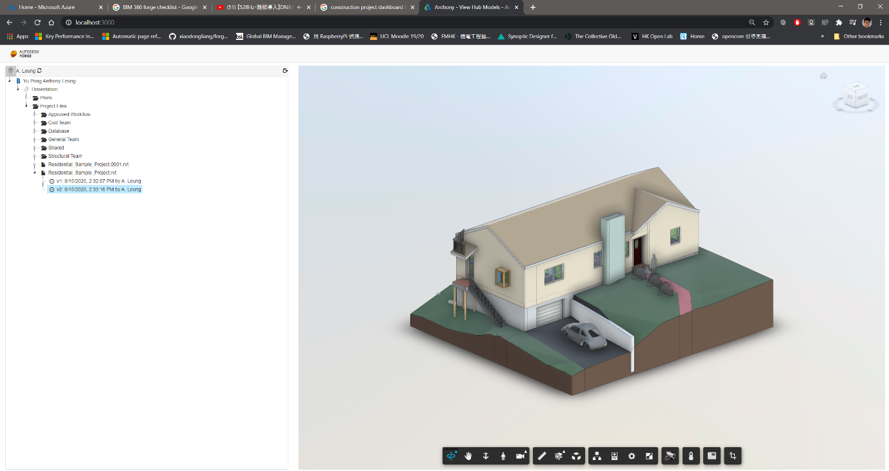

# Limitation

The forge API is not easy for the beginners to use. Although Autodesk already provide different documentation on the internet, it is highly fragmented and not easy to start with. The Author originally want to develop an external web viewer application which integrate the sensory data into the BIM model data for visualisation. However, it is very difficult to manually to integrate the viewer application and the sensory data by coding.

# Recommendation

Regarding to this issue, it is suggested that a visual programming interface should be provided on this API feature of the Control Room so that the user can more easily to customise how to push to and get data from other external applications. Since sharing data by API is very common and as technology in AEC industry is not highly adopted and less IT expert, a visual programming interface can set a good starting point for the construction professional to use.

Besides, as there are different external proprietary mobile applications used by the Contractor to record the works of the frontline workers in the construction site, the API of the Control Room should have the capability to get the data from these external applications to ensure the project data can be more integrated and stored in the CDE.

# Day-to-day routine of Control Room

A day-to-day operation on the residential house design and build project with the Control Room can be illustrated as follows.

The structural engineer can access to the BIM 360 platform to understand the status of different workflow requested for approval, RFI submitted by team members at ”Project Home” page. Then he can use the local software Revit to access to the BIM model data stored in BIM 360 to review and modify the model. If the structural engineer not sure whether his modification on the model can fulfil the need by the Architect, so they can hold a VR remote meeting to present themselves in the model, they can discuss together in a 3D immersive environment to comprise a design which can fulfil the need of both teams. It can increase the productivity and avoid the re-do works. During the construction stage, the engineer can use the dashboard to realise the environment condition of the construction site based on the real time sensory data to check whether the working environment is suitable for the workers. If the temperature always above the threshold of working, the engineers should ask the workers to take regular breaks to maintain their health to work.

Apart from the project engineers, the project managers and project directors can make use of the dashboard to oversee the accidents record at the construction site to identify which locations, construction activities will cause high safety risk so that they can set up strategy to mitigate the safety deficiency such as provide extra PPE when concreting at basement and set up goals to maintain the safety record and ask the project engineer to keep on monitoring it. They can also use the VR visualisation on BIM model data to conduct a walk-though in an immersive 3D environment for site inspection to identify any location with high risk during construction and the construction constraint to facilitate their planning of resources and cost in the project.

By using this Control Room, from project engineers to project directors can make use of the data to manage the design, workflow approval and understand the working environment for workers and set-up goals for safety and progress of a construction project. Besides, this Control Room platform is web-based, so they can use this platform to work remotely, which is extremely useful if they cannot come back to the office and access to the construction site under disruption such pandemic diseases.

The video link shows the day-to-day operation:

# Evolution in ideal case

In the future study, there are numerous possibilities of the functionality of the Control Room.

perhaps the real-time sensory data can be integrated with the BIM model, so that one can immerse with VR Sensor data in VR. Automation

# Conclusion (Link to Intro, LR)

The applications evaluated in this study give an overview of how the Control Room’s features has been developed in the current market. It shows that from the Project Engineer to the Project Director will also get benefit from it for their day to day operation of a construction project.

Although still in its early days, VR has shown extensive benefits to bring to the architecture and construction industry, from functional and aesthetic evaluation of projects to daylight and lighting studies as well as client collaboration and communication (Corke, 2017).

Through a literature review, it was found that only a handful of available VR applications for architecture and construction uses have been reviewed.

To provide more comprehensive and detailed review on the functionality of a Control Room, this study evaluated multiple functionality that were available on the market recently. Application such as BIM 360, Prospects, Autodesk Forge API, Microsoft were identified and evaluated.

Their capabilities were evaluated including collaboration, information management, ease to use, forms of visualisation, insight as well as license cost.

Recommendations were given on how should these different feature should be improved to make it to use more effectively and easy to use.

**Evaluate these 4 features!!!**

**-Collaboration Features**

**-Information Management**

**-Data Visualisation**

**-Open API**

# Reference

Alizadehsalehi, S., Hadavi, A., & Huang, J. C. (2019). Virtual reality for design and construction education environment. *AEI 2019: Integrated Building Solutions - The National Agenda - Proceedings of the Architectural Engineering National Conference 2019*. https://doi.org/10.1061/9780784482261.023

Belizario, M. G., & Berardi, R. C. G. (2019). Use of Smart and Open Data in Smart Cities. In *25th Americas Conference on Information Systems (AMCIS 2019)*.

Bennett, S. (1993). A History of Control Engineering 1930-1955. In *A History of Control Engineering 1930-1955*. https://doi.org/10.1049/pbce047e

Boje, C., Guerriero, A., Kubicki, S., & Rezgui, Y. (2020). Towards a semantic Construction Digital Twin: Directions for future research. In *Automation in Construction*. https://doi.org/10.1016/j.autcon.2020.103179

Bolton, A., Butler, L., Dabson, I., Enzer, M., Evans, M., Fenemore, T., & Harradence, F. (2018). The Gemini Principles. *University of Cambridge, UK 2018*. https://doi.org/10.17863/CAM.32260

Brandon, J. (2020). *VR is the future of remote working*. https://www.techradar.com/news/vr-is-the-future-of-remote-working

Changali, S., Mohammad, A., & Van Nieuwland, M. (2015). The construction productivity imperative. *McKinsey Quarterly*.

*Design–build*. (2011). https://en.wikipedia.org/wiki/Design–build

Engineers, I. of C. (2018). *P13 Blue Print*.

Freina, L., & Ott, M. (2015). A literature review on immersive virtual reality in education: State of the art and perspectives. *Proceedings of ELearning and Software for Education (ELSE)(Bucharest, Romania, April 23--24, 2015)*. https://doi.org/10.12753/2066-026X-15-020

HSE. (2019). Work-related stress , anxiety or depression statistics in Great Britain , 2019. *Annual Statistics*.

Jarrett Hendricks. (2020). *Rise of the Digital Twin: How Lessons Learned from NASA Are Changing the Way Supply Chains Are Managed*. https://info.expeditors.com/horizon/rise-of-the-digital-twin

Keil, S., Lasch, R., Lindner, F., & Lohmer, J. (2019). *A Holistic Digital Twin Based on Semantic Web Technologies to Accelerate Digitalization*.

Lara, A. P., Da Costa, E. M., Furlani, T. Z., & Yigitcanlar, T. (2016). Smartness that matters: Towards a comprehensive and human-centred characterisation of smart cities. *Journal of Open Innovation: Technology, Market, and Complexity*. https://doi.org/10.1186/s40852-016-0034-z

Levine, T. (2016). *Using Communication and Collaboration Technology to Keep Construction Projects On Schedule and On Budget*.

Li, X., Yi, W., Chi, H. L., Wang, X., & Chan, A. P. C. (2018). A critical review of virtual and augmented reality (VR/AR) applications in construction safety. *Automation in Construction*. https://doi.org/10.1016/j.autcon.2017.11.003

McKinsey. (2015). The MGI Industry Digitization Index. *McKinsey Global Institute*.

McKinsey & Company. (2017). Reinventing Construction: A Route To Higher Productivity. *McKinsey & Company*.

Microsoft. (2020). *Azure Cloud Services*. https://azure.microsoft.com/en-us/overview/what-is-cloud-computing/

Mohd Nawi, M. N., Baluch, N., & Bahauddin, A. Y. (2014). Impact of fragmentation issue in construction industry: An overview. *MATEC Web of Conferences*. https://doi.org/10.1051/matecconf/20141501009

StarCompliance. (2019). *Compliance Control Room: What Is It And Who Needs It?* https://blog.starcompliance.com/control-room-what-is-it-and-who-needs-it

Stergiou, C., Psannis, K. E., Kim, B. G., & Gupta, B. (2018). Secure integration of IoT and Cloud Computing. *Future Generation Computer Systems*. https://doi.org/10.1016/j.future.2016.11.031

Woodhead, R., Stephenson, P., & Morrey, D. (2018). Digital construction: From point solutions to IoT ecosystem. *Automation in Construction*. https://doi.org/10.1016/j.autcon.2018.05.004

Xu, S., & Luo, H. (2014). The information-related time loss on construction sites: A case study on two sites. *International Journal of Advanced Robotic Systems*. https://doi.org/10.5772/58444

Yi, Y., Yan, Y., Liu, X., Ni, Z., Feng, J., & Liu, J. (2020). Digital twin-based smart assembly process design and application framework for complex products and its case study. *Journal of Manufacturing Systems*. https://doi.org/10.1016/j.jmsy.2020.04.013

# Research Log

|  |  |  |
| --- | --- | --- |
|  |  |  |
|  |  |  |
|  |  |  |
|  |  |  |
|  |  |  |
|  |  |  |

# Appendix

Coding, github

1. Design and Build Project means that design and construction ongoing at the same time (*Design–build*, 2011)
2. Reference Link: <https://projectdataanalytics.uk/past-events/projecthack5-output>